# **Structure of an AI Agent**

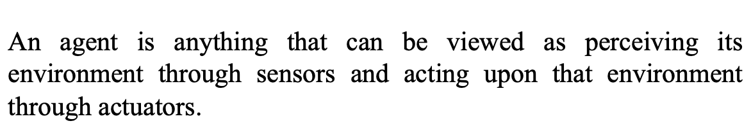

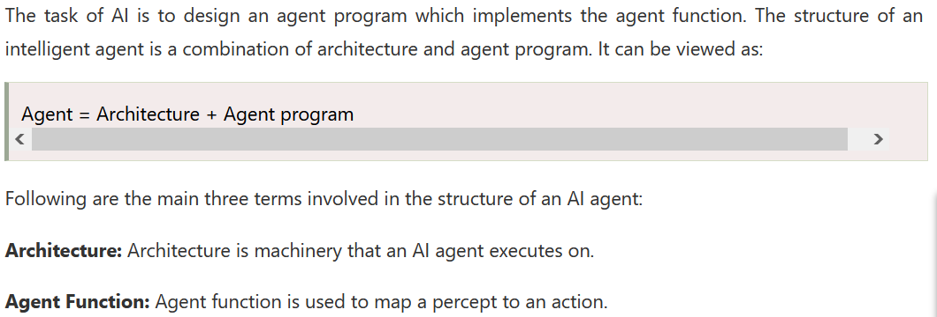  
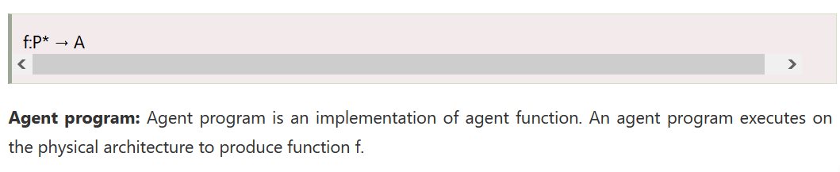

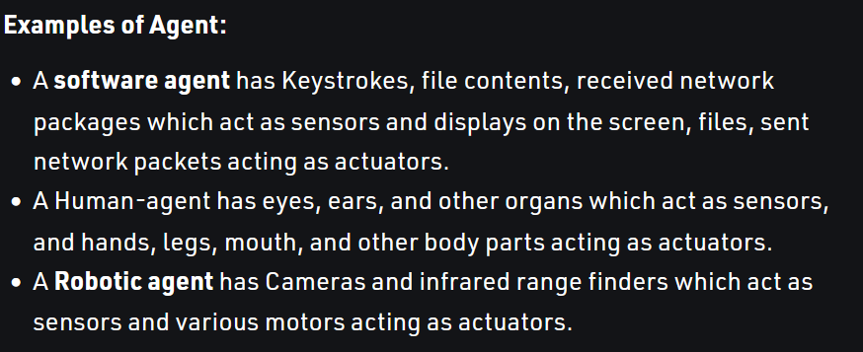

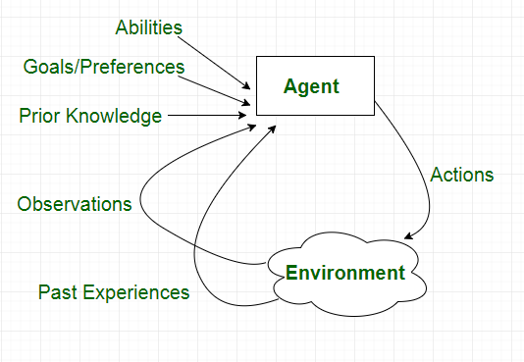

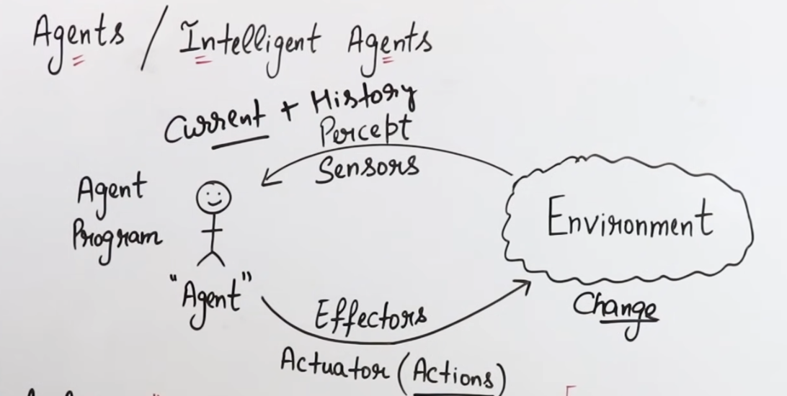

With the help of agent program, agent can able to take a decision.

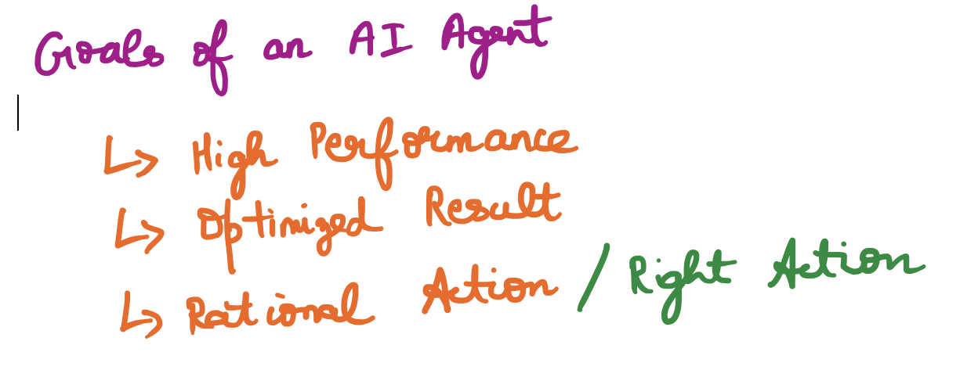

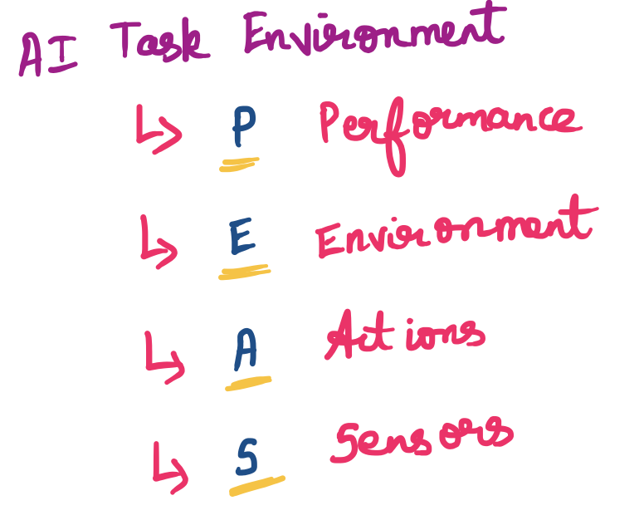

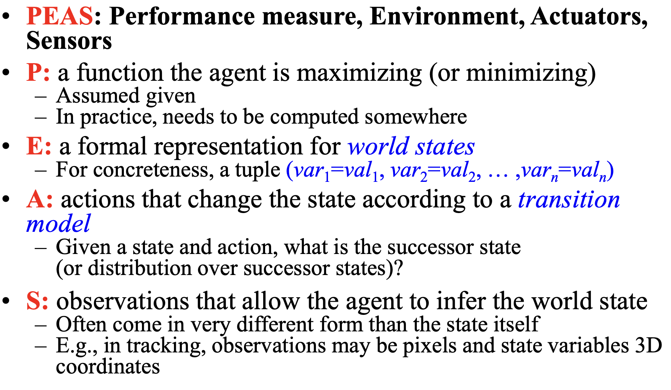

## **Sensors**



## **Actuators**

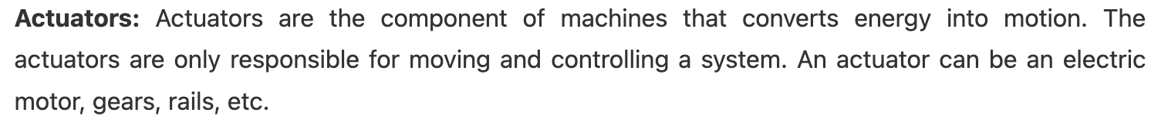

* An actuator is the actual mechanism that enables the effectors to execute an action.
* Typically include:

– electric motors  
 – hydraulic cylinders  
 – pneumatic cylinders.

## **Effectors**



* An effector is any device that affects the environment.
* A robot’s effector is controlled by the robot.
* Effectors can range from legs and wheels to arms and fingers.
* Controller has to get effectors to produce desired effect on the environment, based on robot’s task.

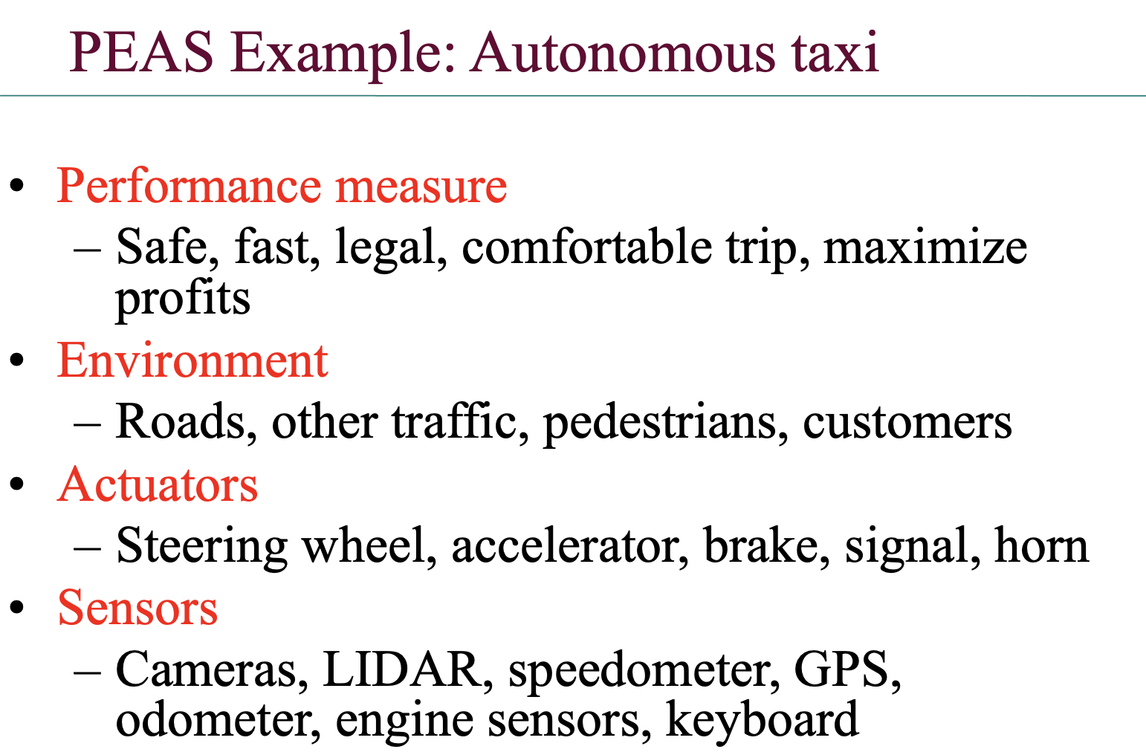

###################### ------------------------- ########################

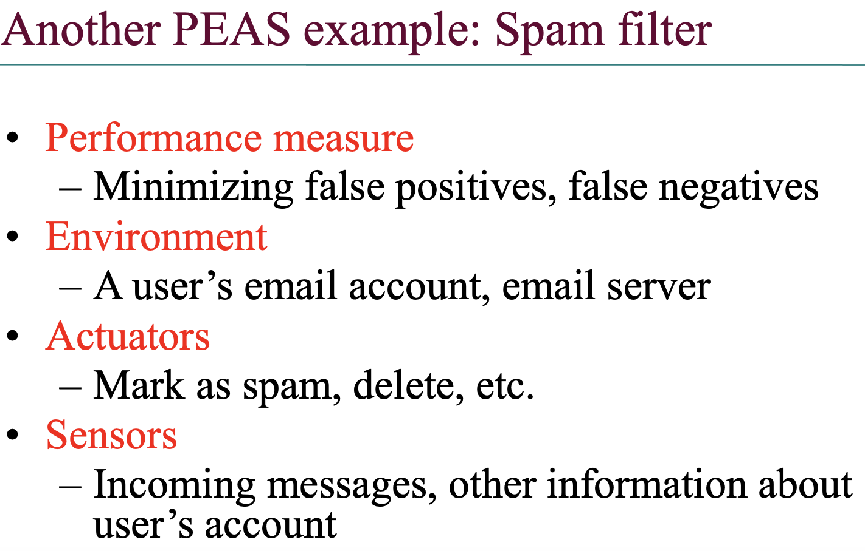

###################### ------------------------- ########################

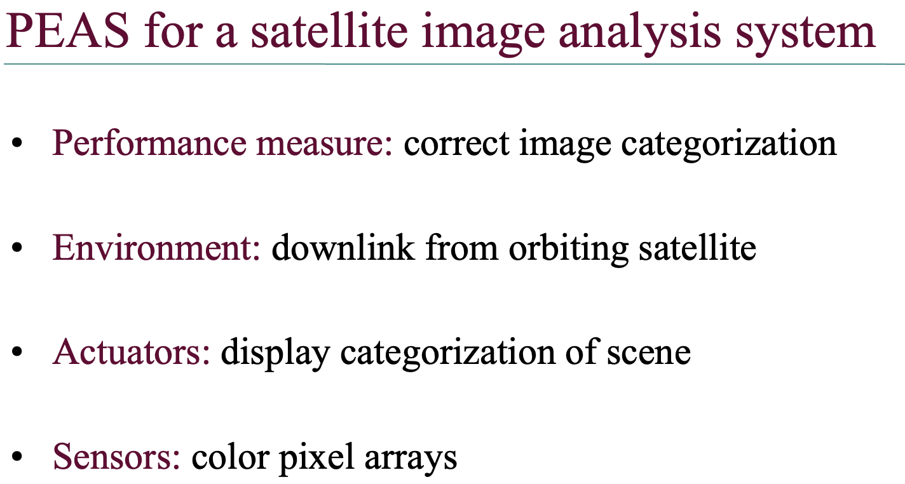

###################### ------------------------- ########################

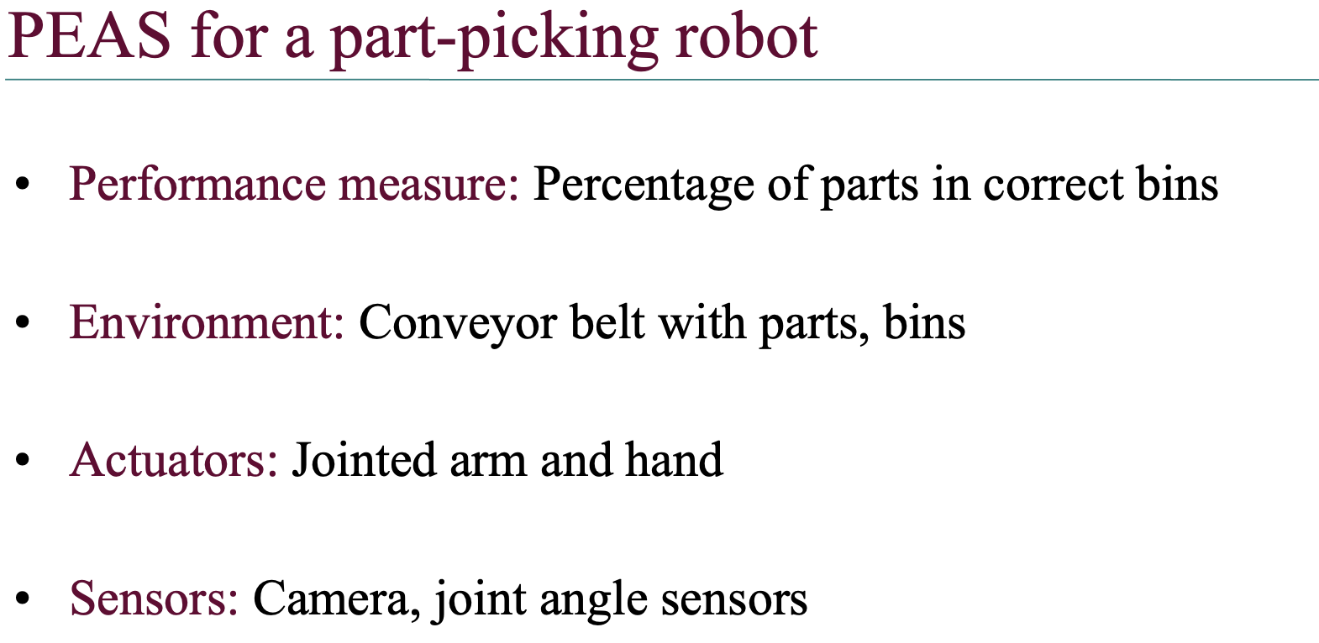

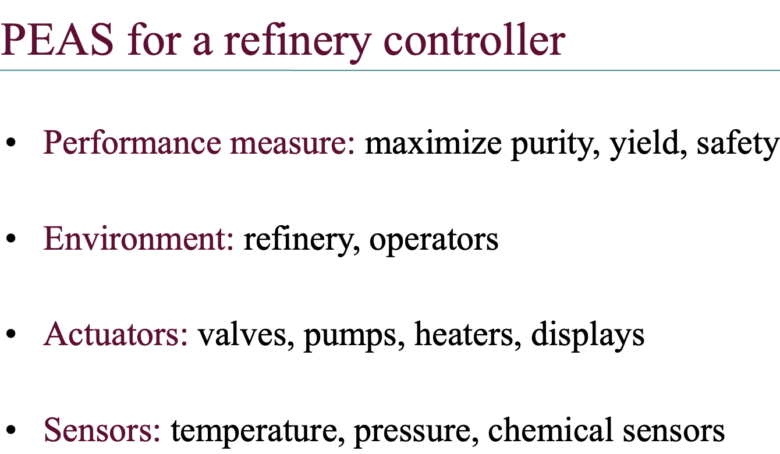

###################### ------------------------- ########################

# **Table Driven Agent**

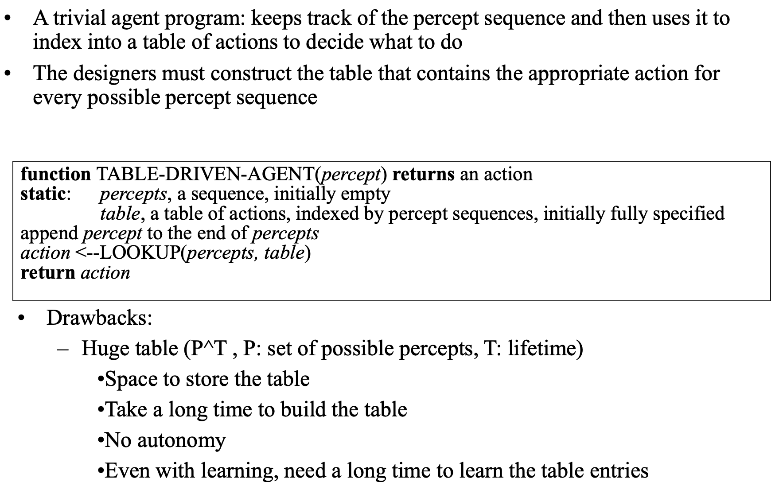

# **Intelligent Agents**

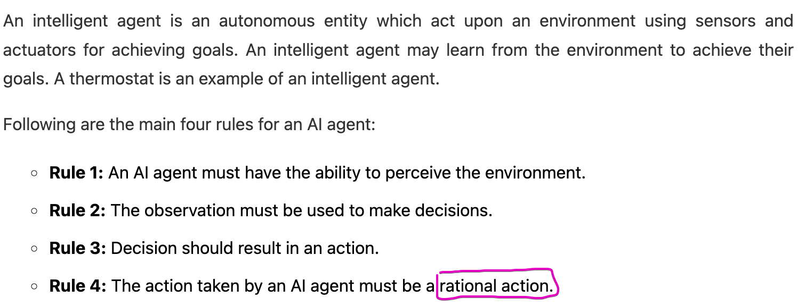

rational 🡪 follow some rules & ethics & logics (not affect by any cause)

irrational 🡪 will not follow the above & it will do whatever it think   
(istha maithukku thondratha pannum || affects by external cause)

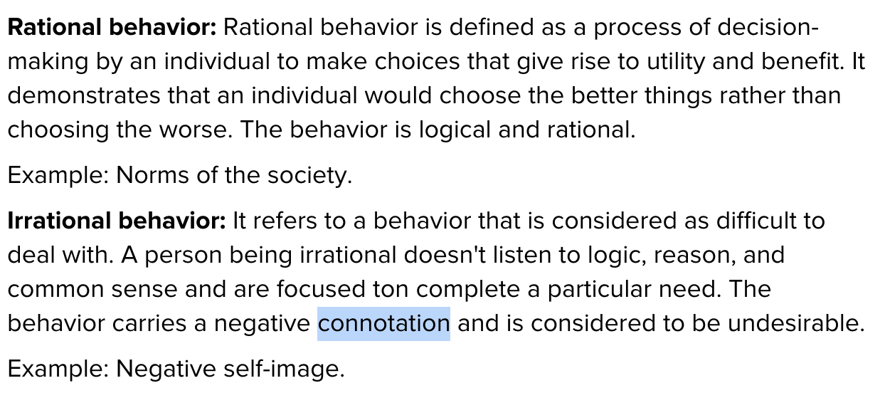

# **Rational Agents**

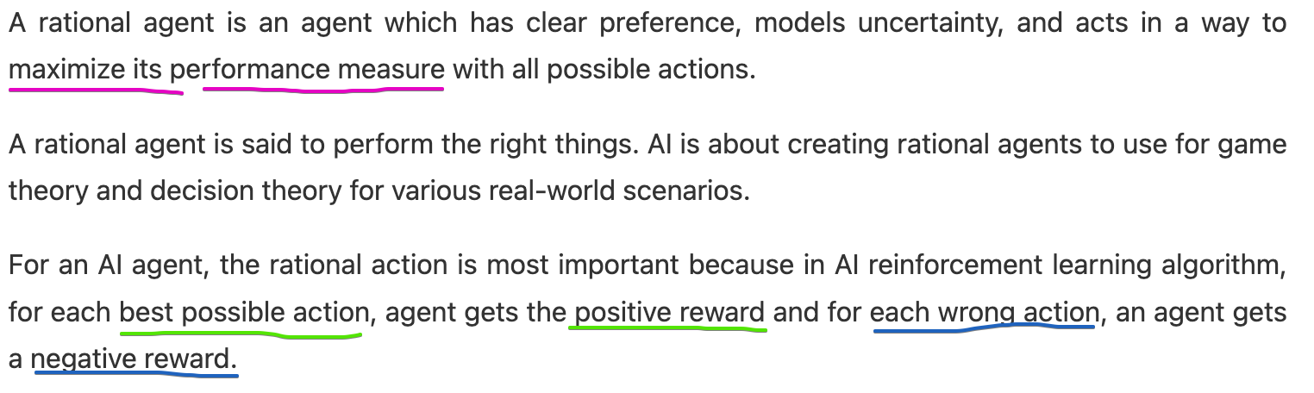

# **Rationality**

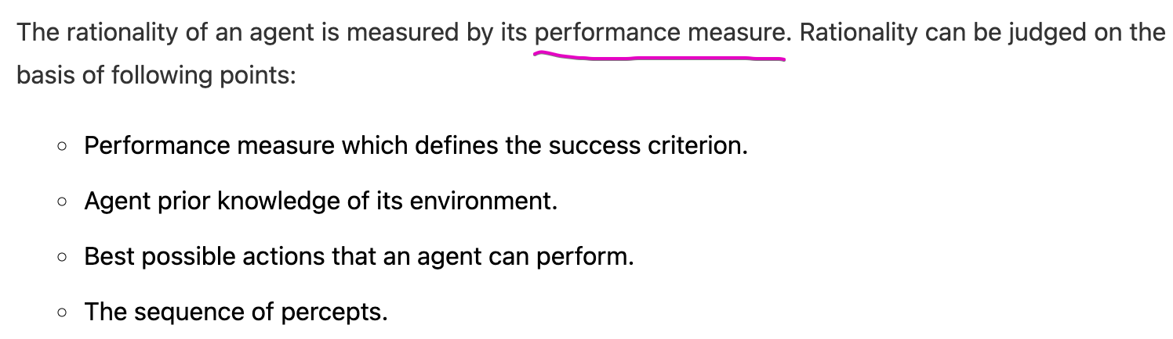

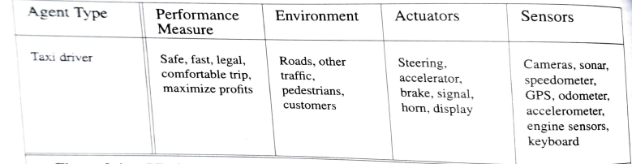

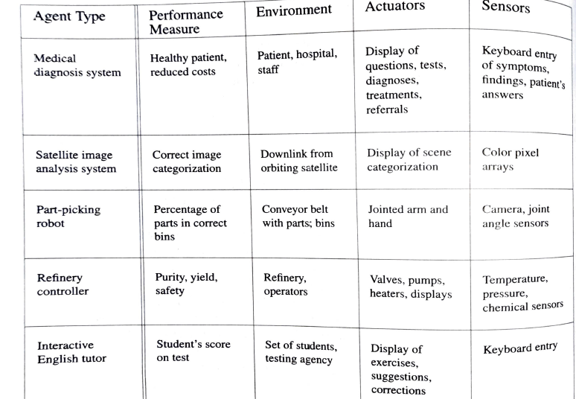

For each of the following activities, give a PEAS description of the task environment and characterize it in terms of the properties listed

• Playing soccer.

• Exploring the subsurface oceans of Titan.

• Shopping for used AI books on the Internet.

• Playing a tennis match.

• Practicing tennis against a wall.

• Performing a high jump.

• Knitting a sweater.

• Bidding on an item at an auction.

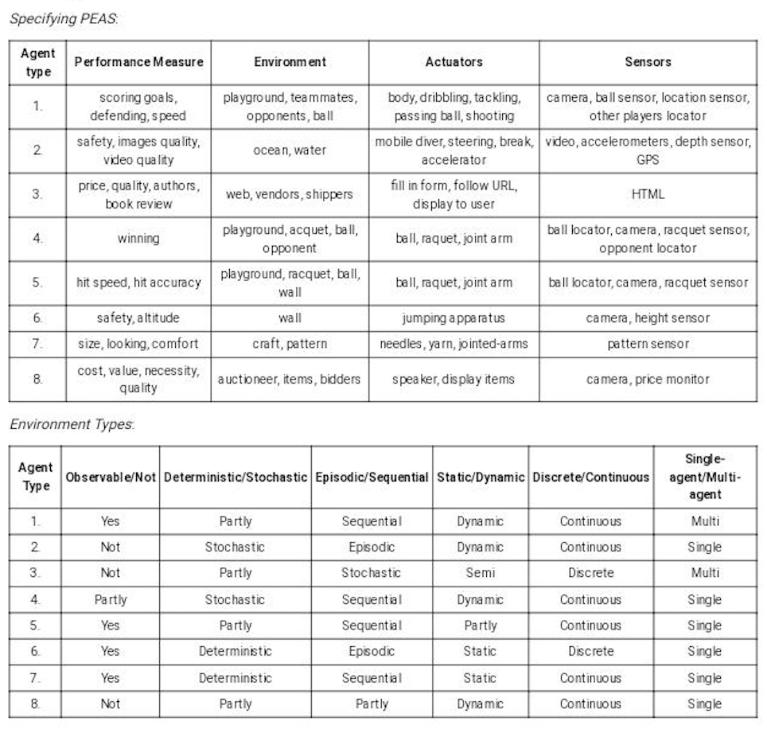

a) Can there be more than one agent program that implements a given agent function? Give an example, or show why one is not possible.

b) Are there agent functions that cannot be implemented by any agent program?

c) Given a fixed machine architecture, does each agent program implement exactly one agent function?

d) Given an architecture with n bits of storage, how many different possible agent programs are there?

e) Suppose we keep the agent program fixed but speed up the machine by a factor of two. Does that change the agent function?

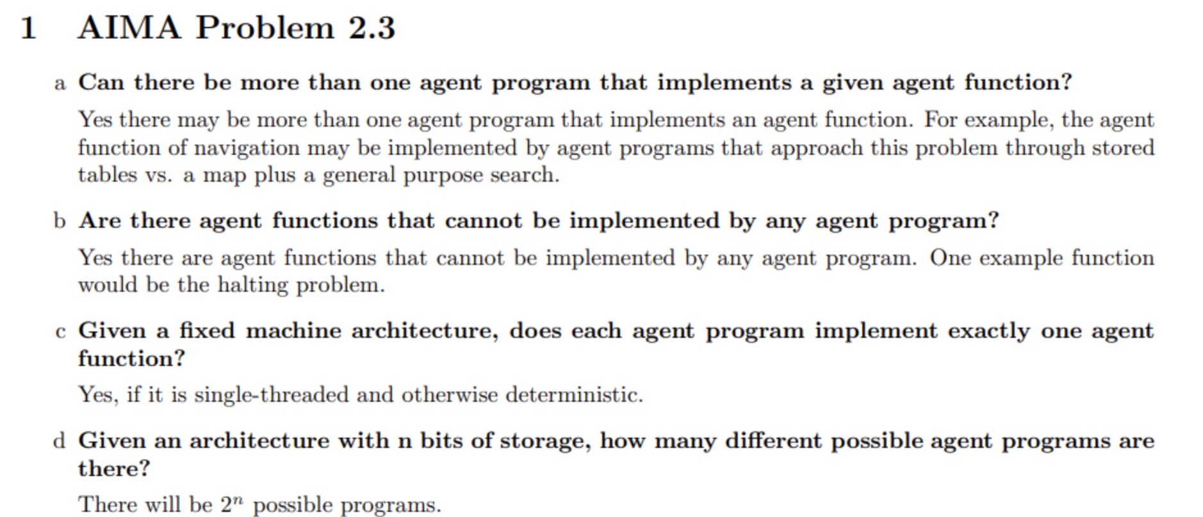

# **Agent Environments**

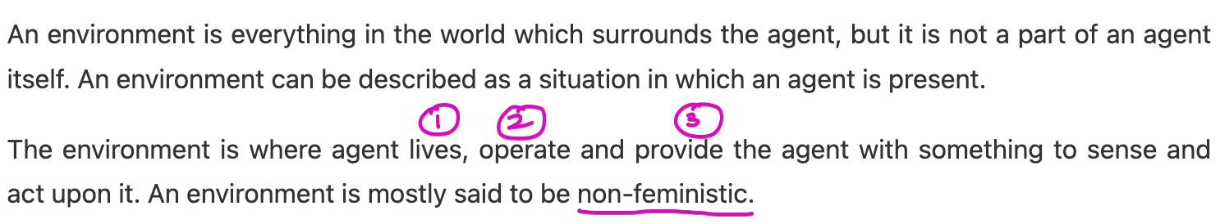

## **Fully Observable vs Partially Observable Environment**

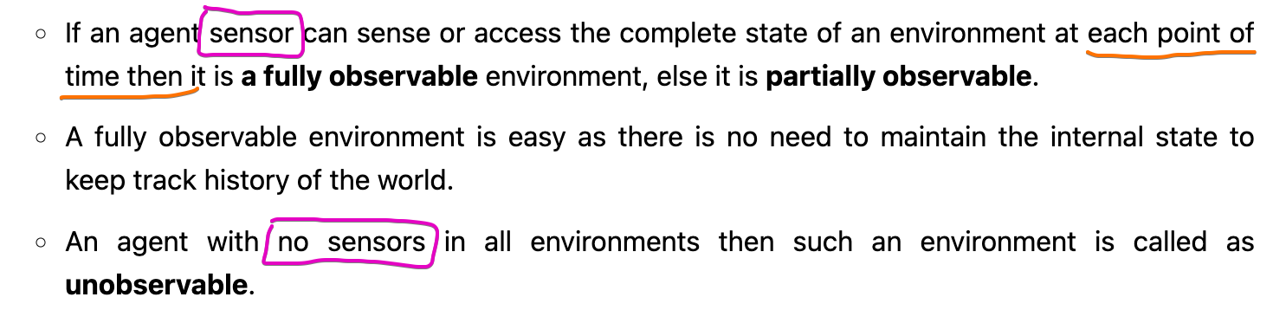  
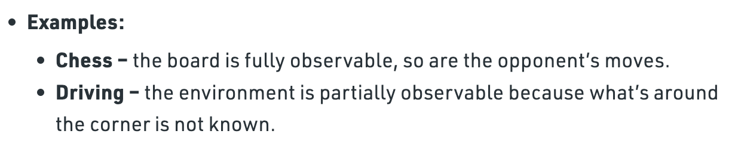

## **Deterministic vs Stochastic Environment**

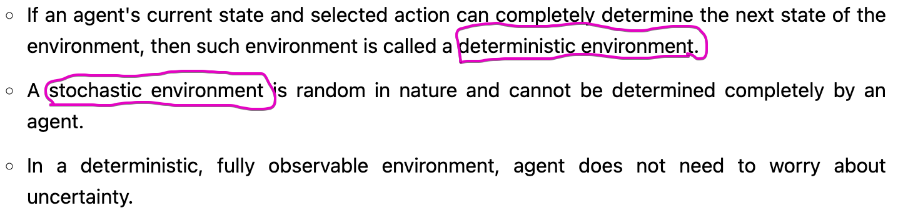

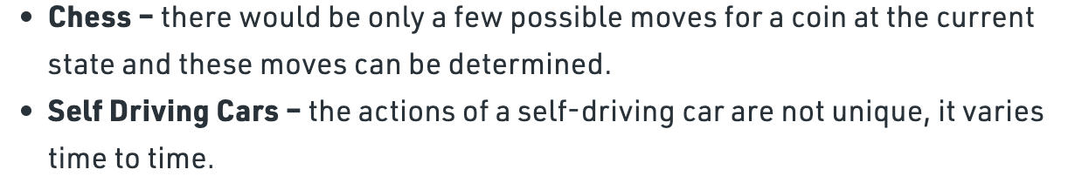

## **Competitive vs Collaborative Environment**

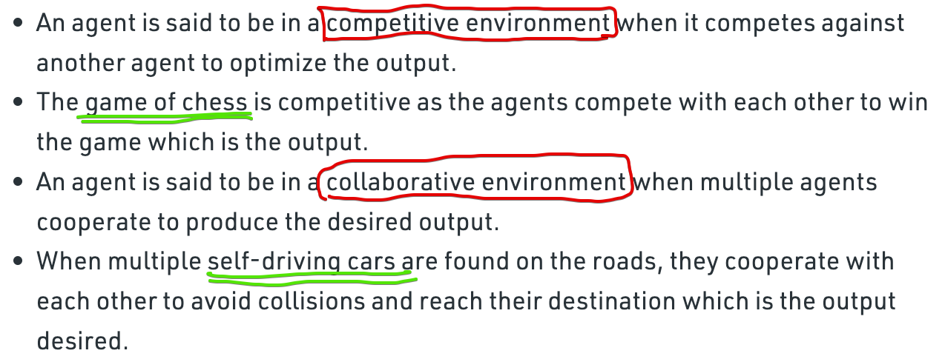

## **Static vs Dynamic Environment**

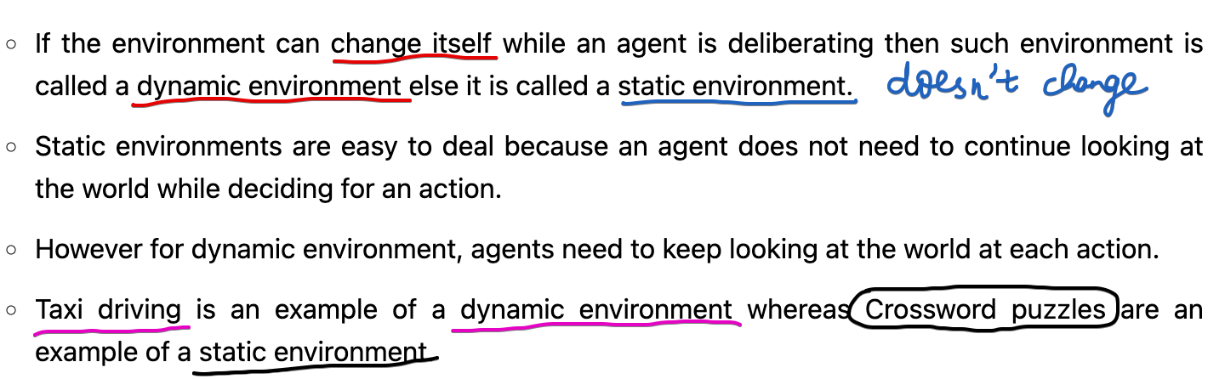

## **Discrete vs Continuous Environment**

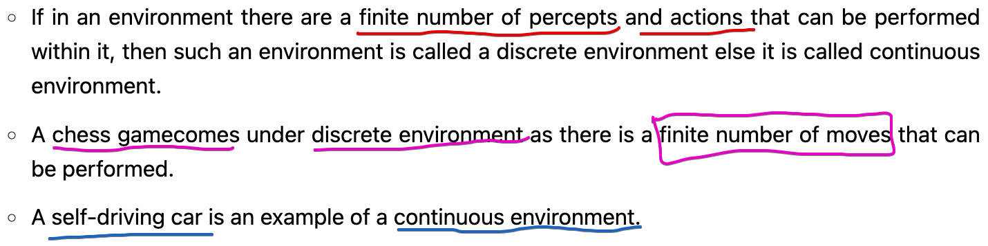

## **Episodic vs Sequential**



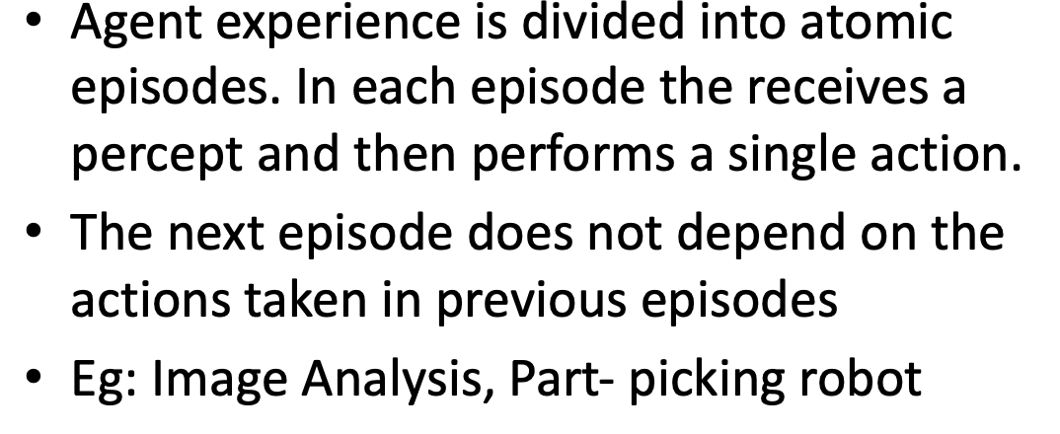



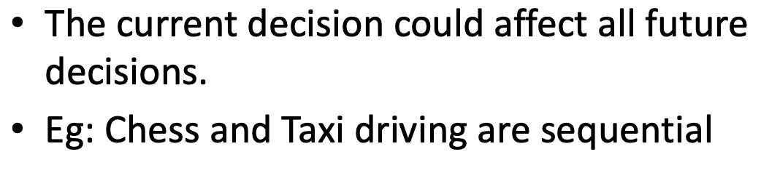  
Episodic environments are much simpler than sequential environment because the agent does not need to think ahead.

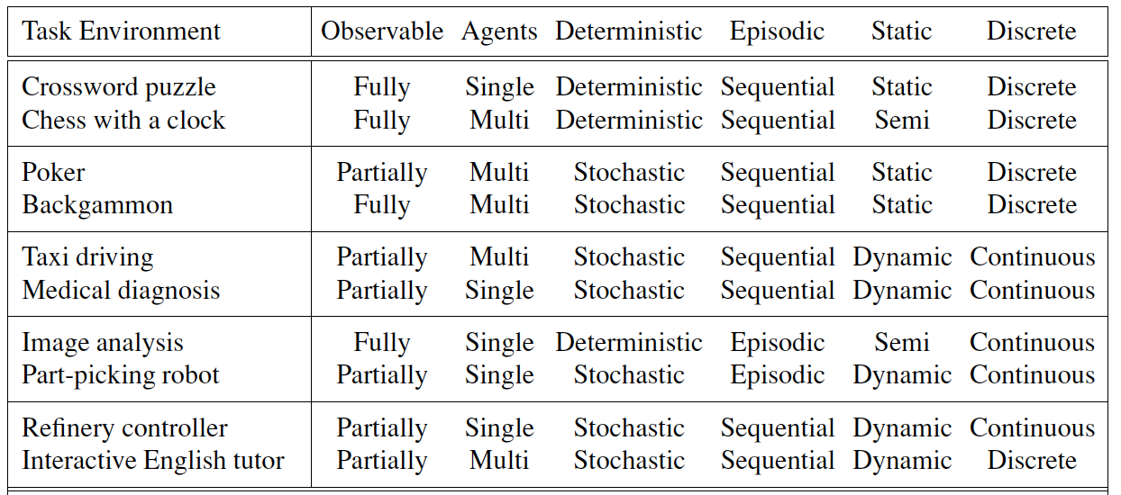

# **AI Agents**

Eg: Sneezing. We not even think, will just sneeze.

Eg: If the car in front brakes and its brake lights come on, then

you should notice this and initiate braking. In other words, some processing is done on the visual input to establish the condition we call “The car in front is braking.” Then, this triggers some established connection in the agent program to the action “initiate braking.” We call such a connection a condition–action rule, written as

*“if car-in-front-is-braking then initiate-braking.”*

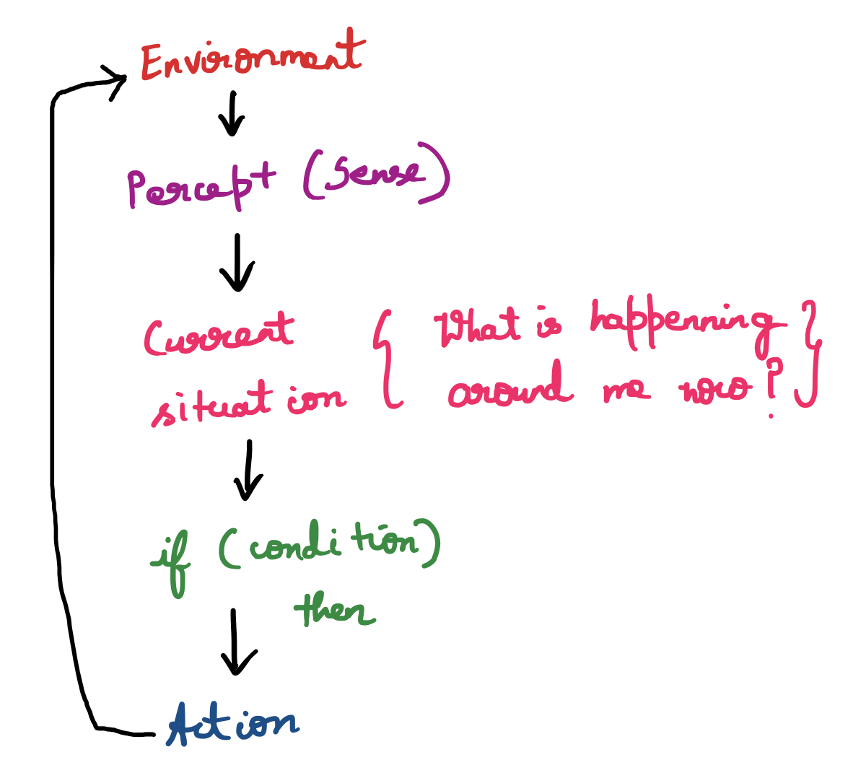

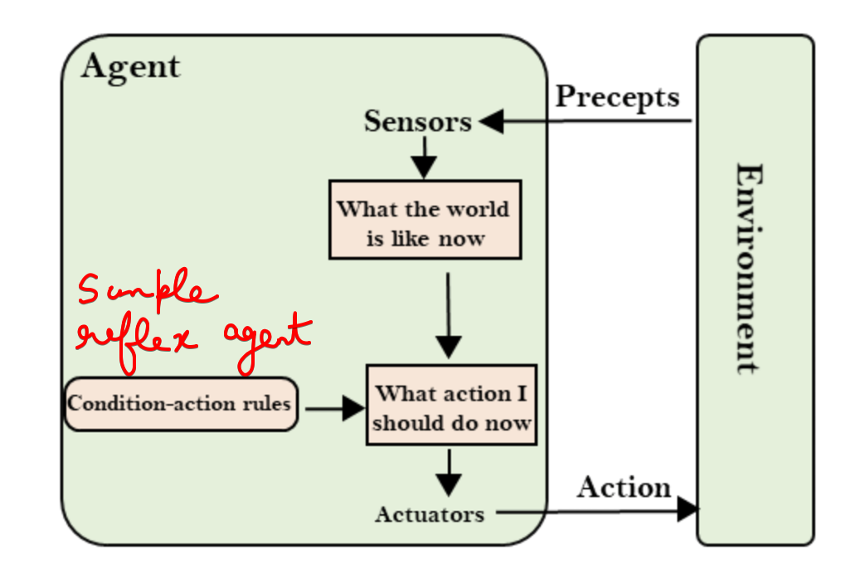

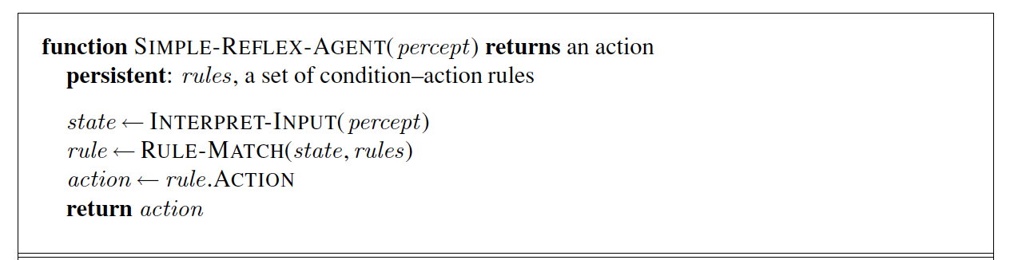

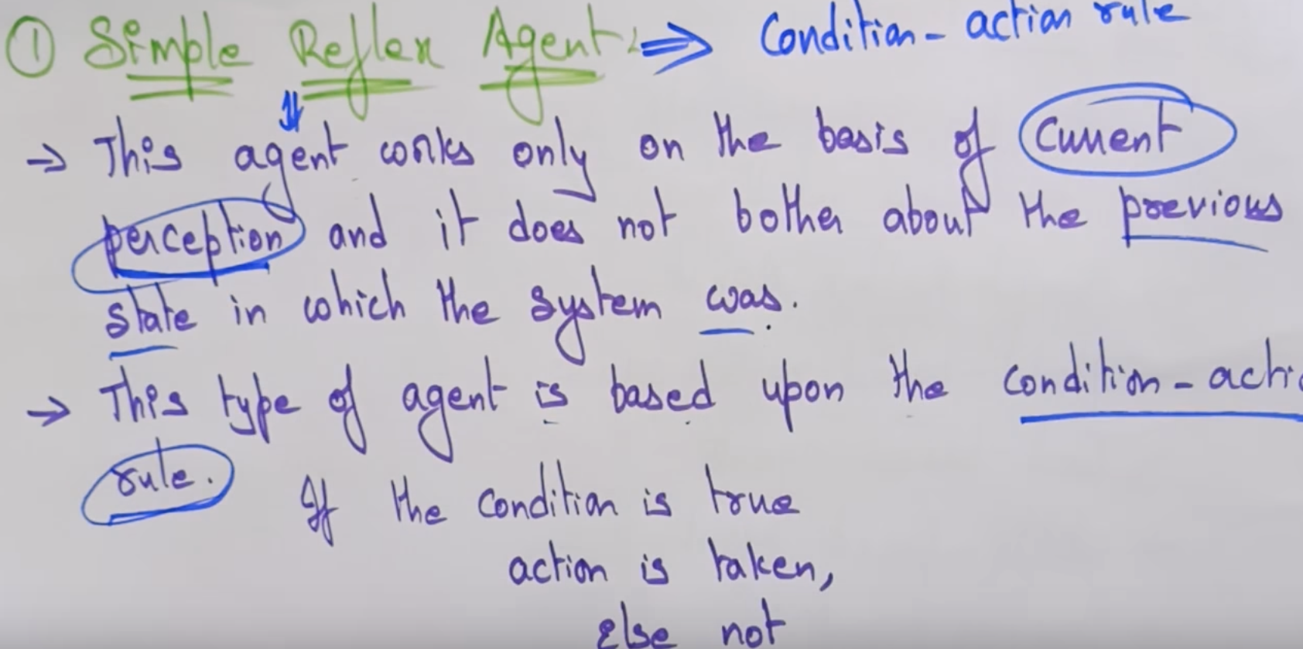

**Eg:** of this class is a **robotic vacuum cleaner** that deliberate in an infinite loop, each percept contains a state of a current location [clean] or [dirty] and accordingly, it decides whether to [suck] or [continue-moving].

Question

Implement a simple reflex agent for the vacuum environment. Run the environment with this agent for all possible initial dirt configurations and agent locations. Record the performance score for each configuration and the overall average score.

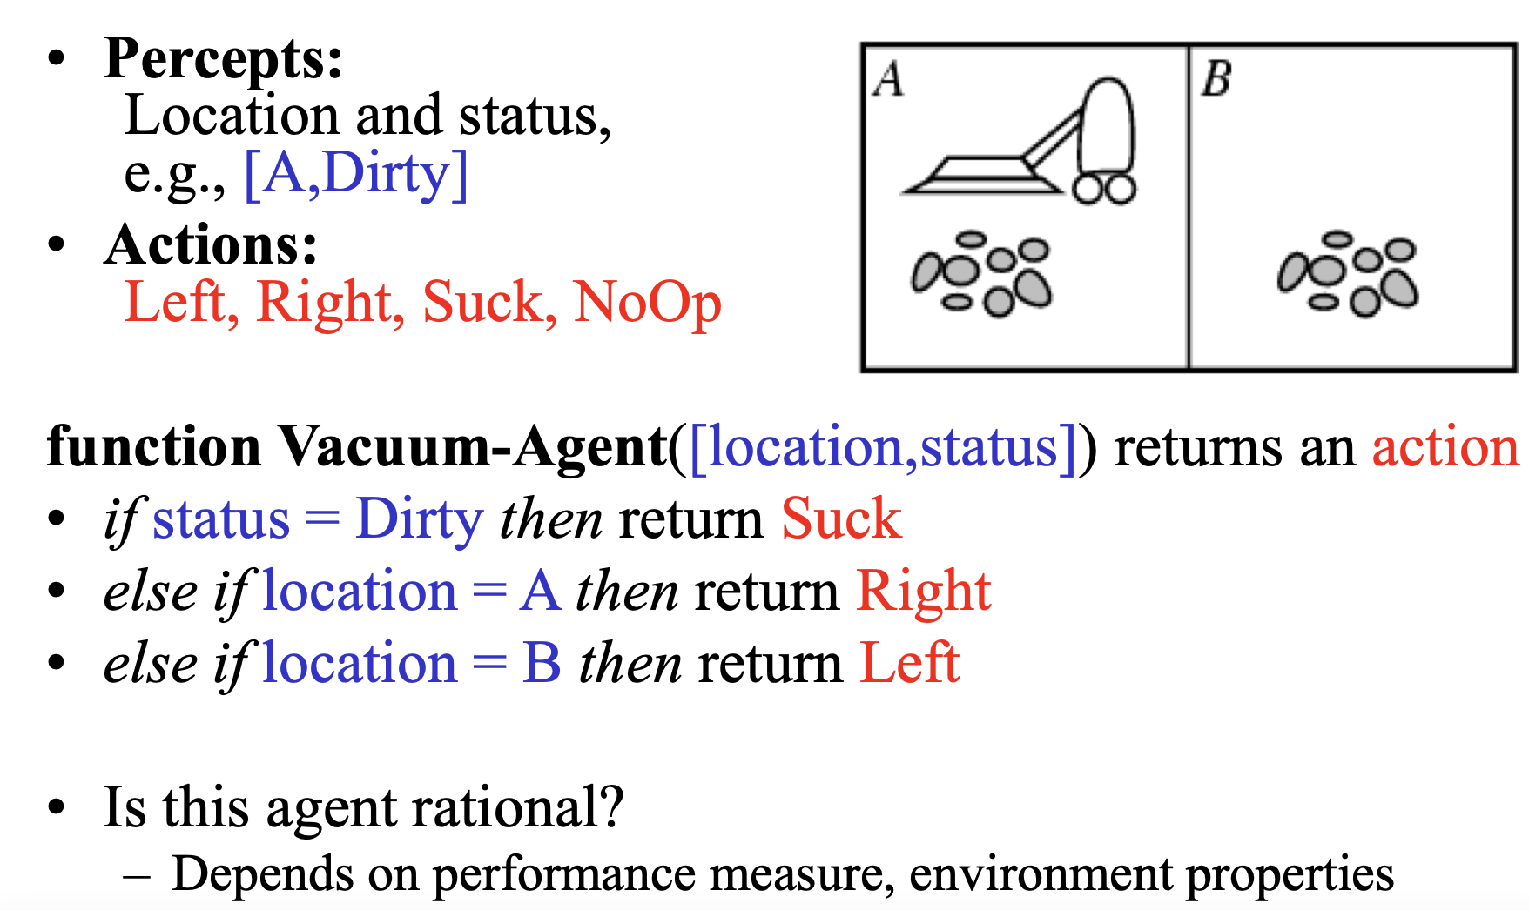



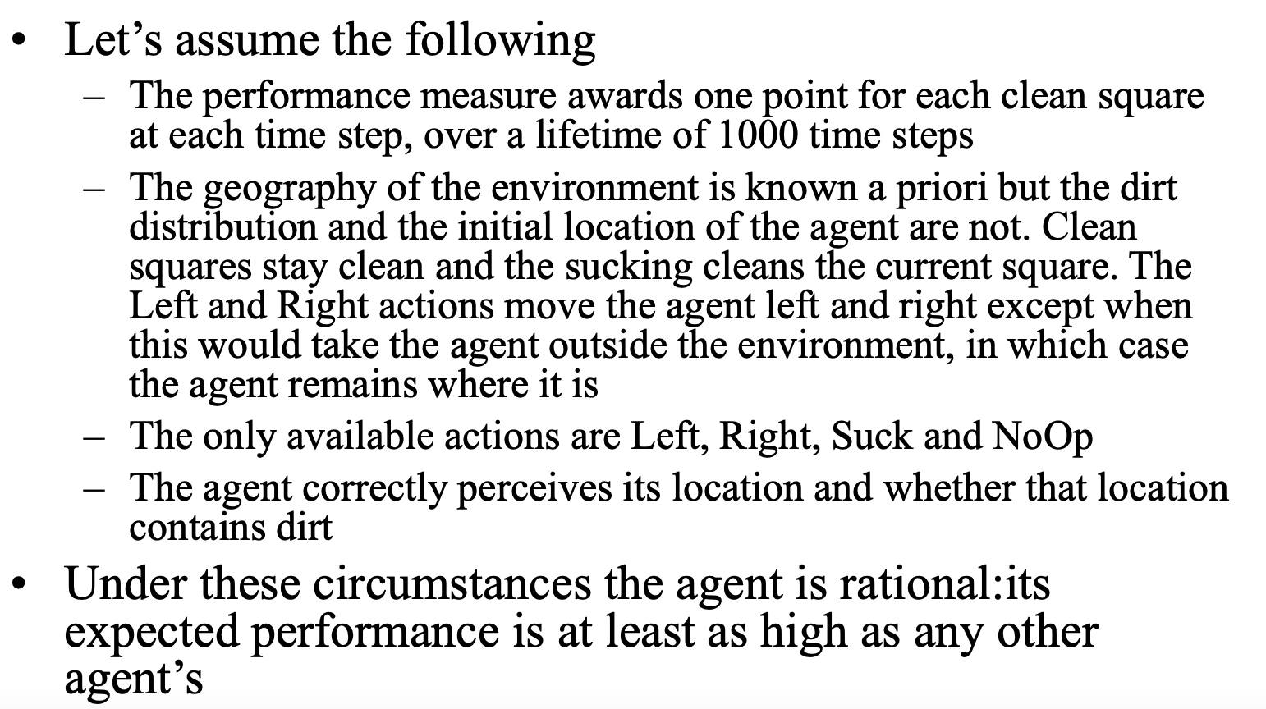

## **Model based Reflexive Agent**

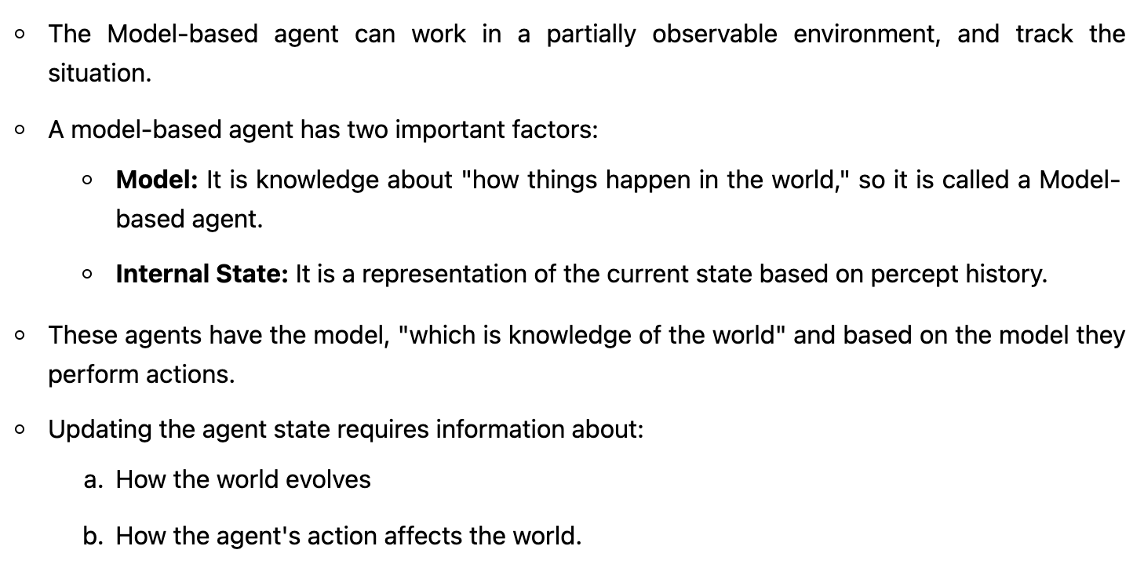



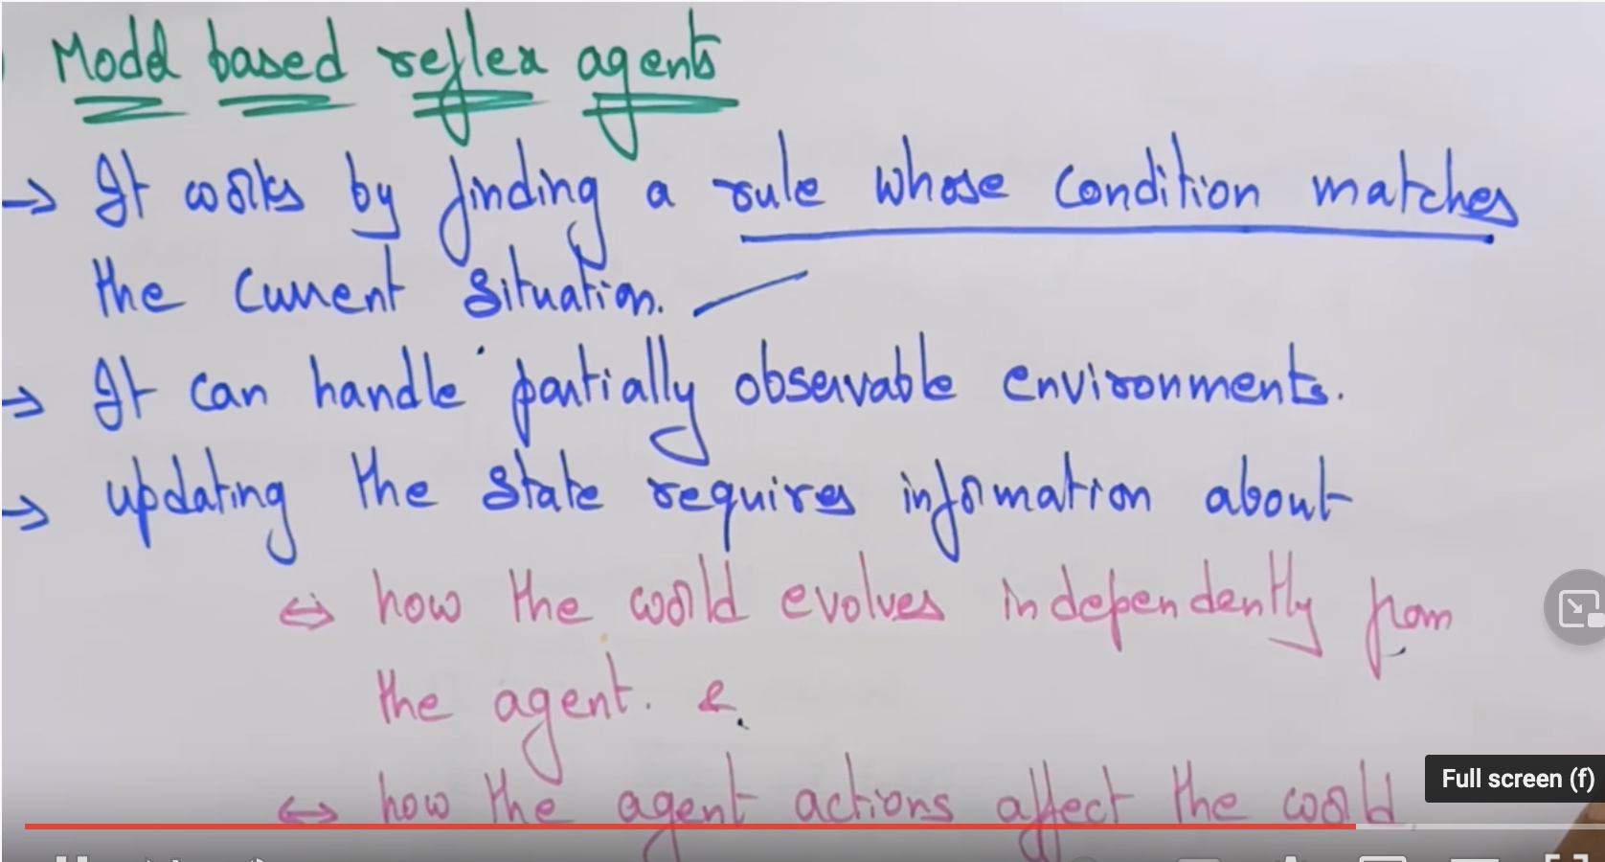

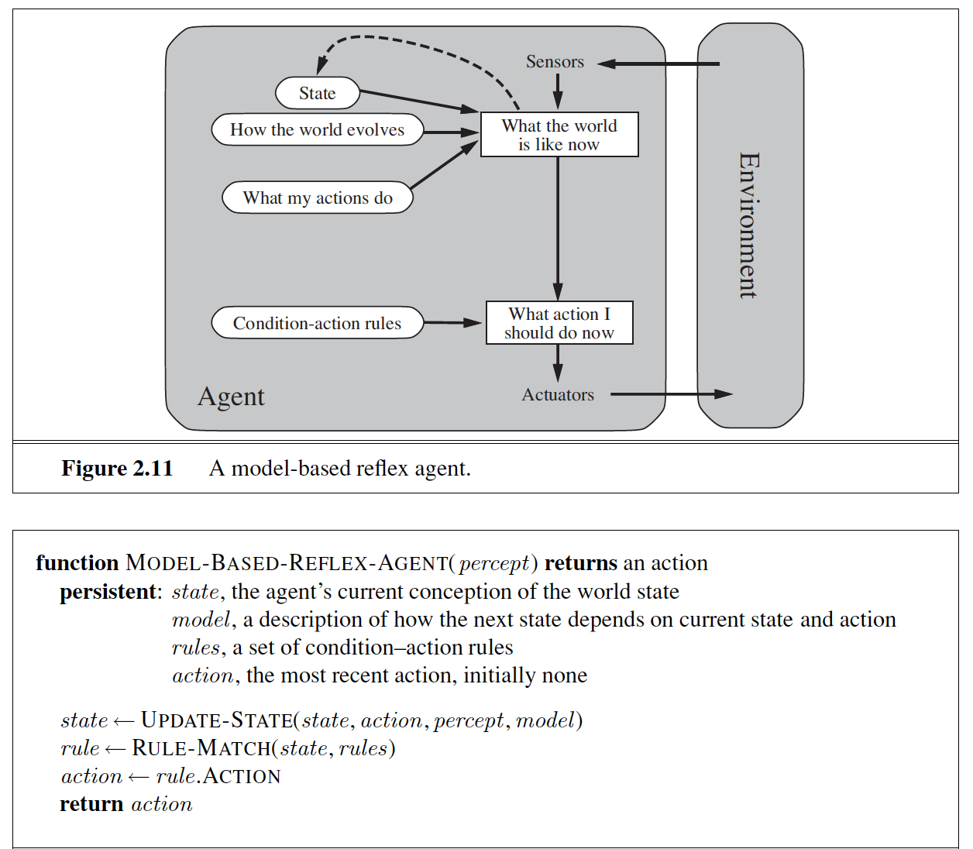

## **Goal based Reflexive Agent**

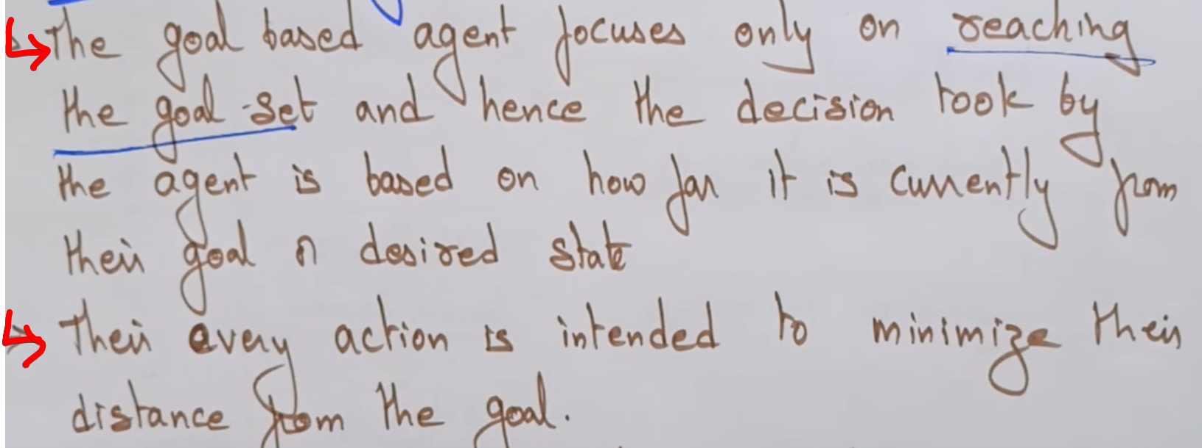  
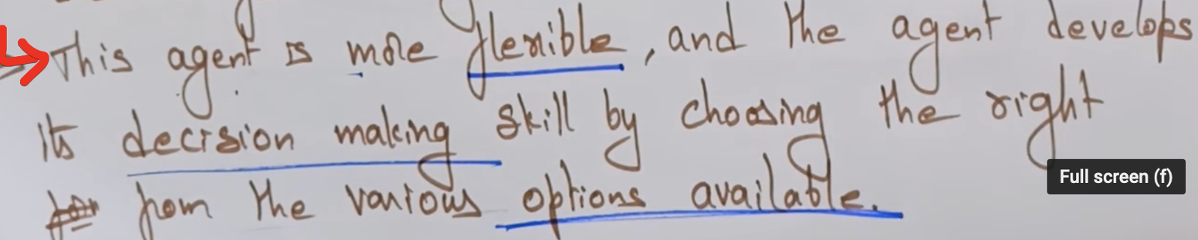

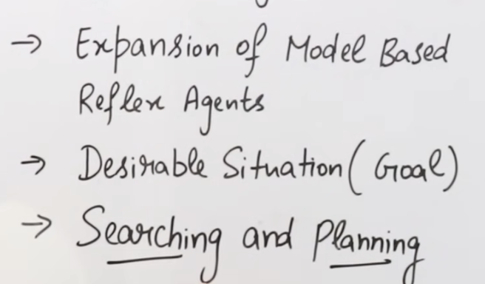

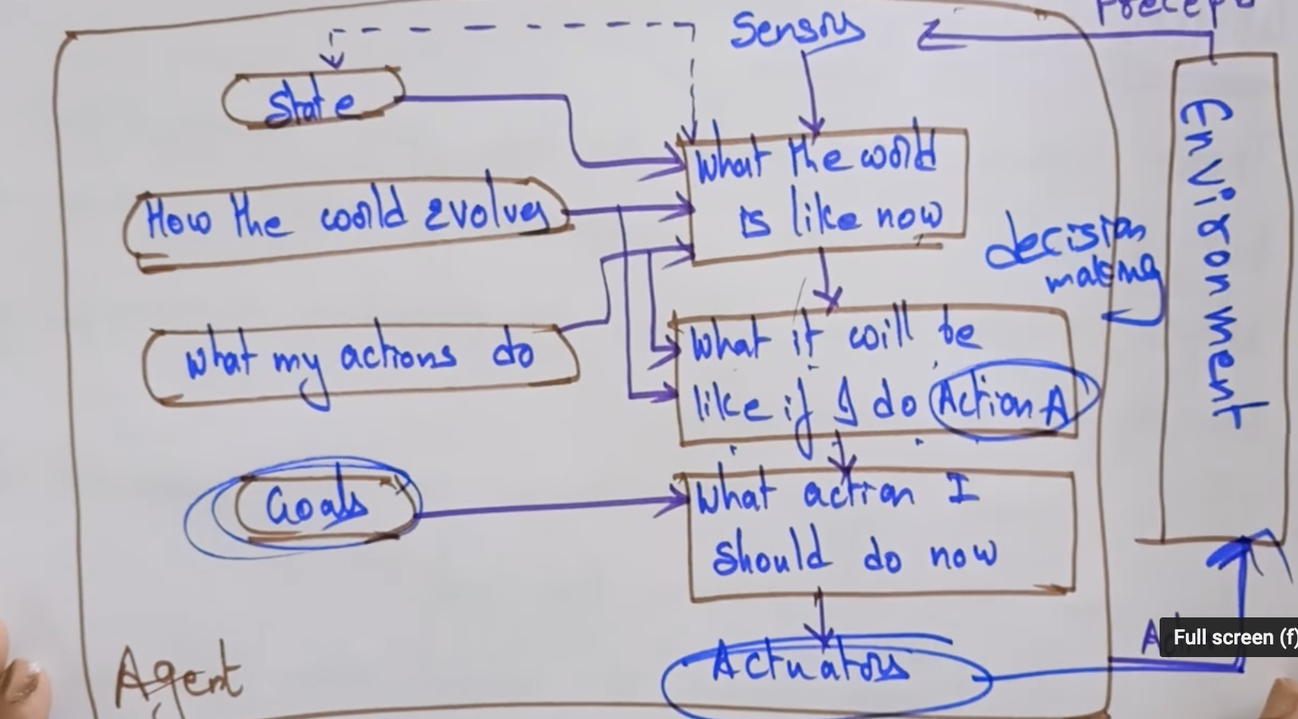 **Eg :** Searching robot that has an initial location and wants to reach a destination.

## **Utility based Reflexive Agent**

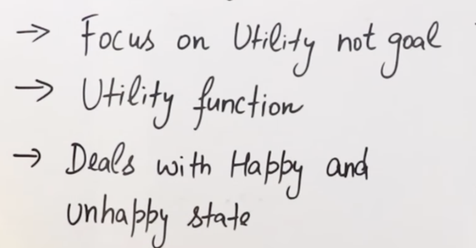

An **utility-based reflex agent** is like the goal-based agent but with a measure of "how much happy" an action would make it rather than the goal-based binary feedback ['happy', 'unhappy'].

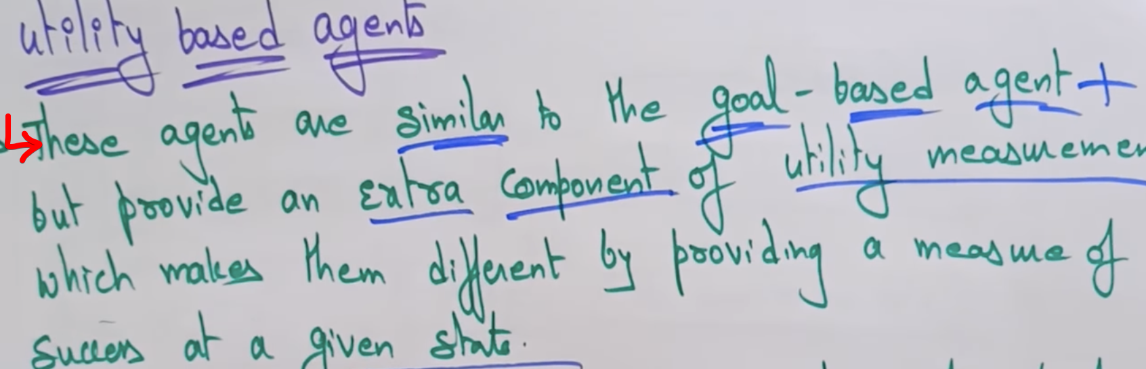

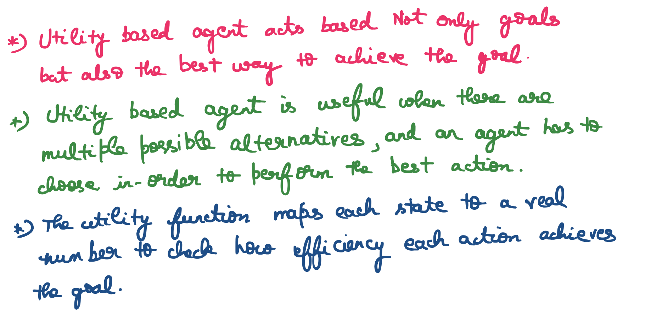

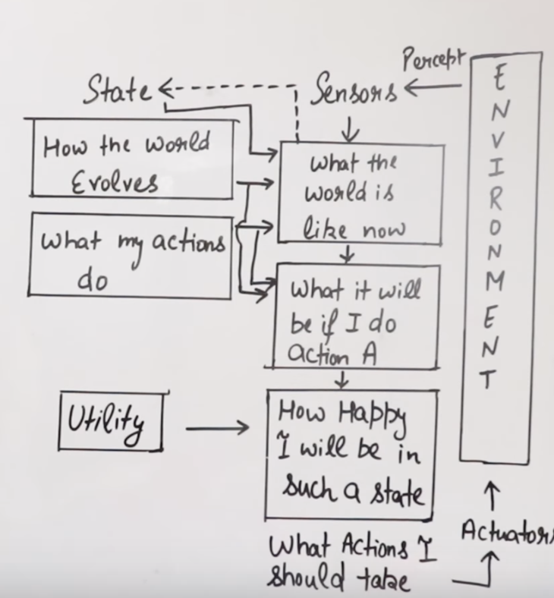

Eg: **route recommendation system** which solves the 'best' route to reach a destination.

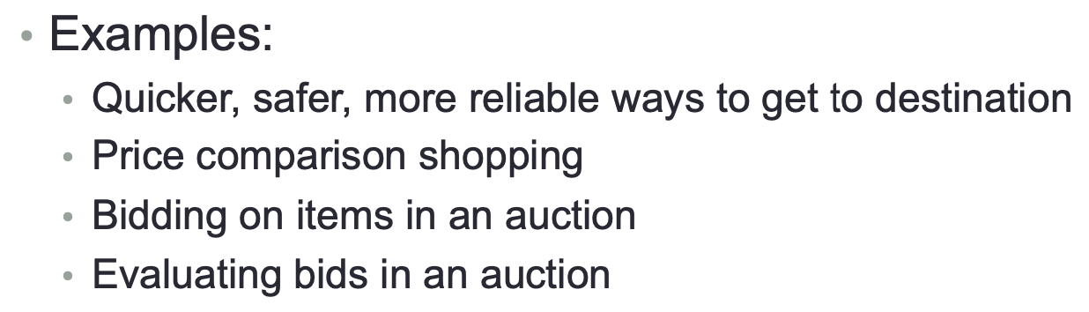

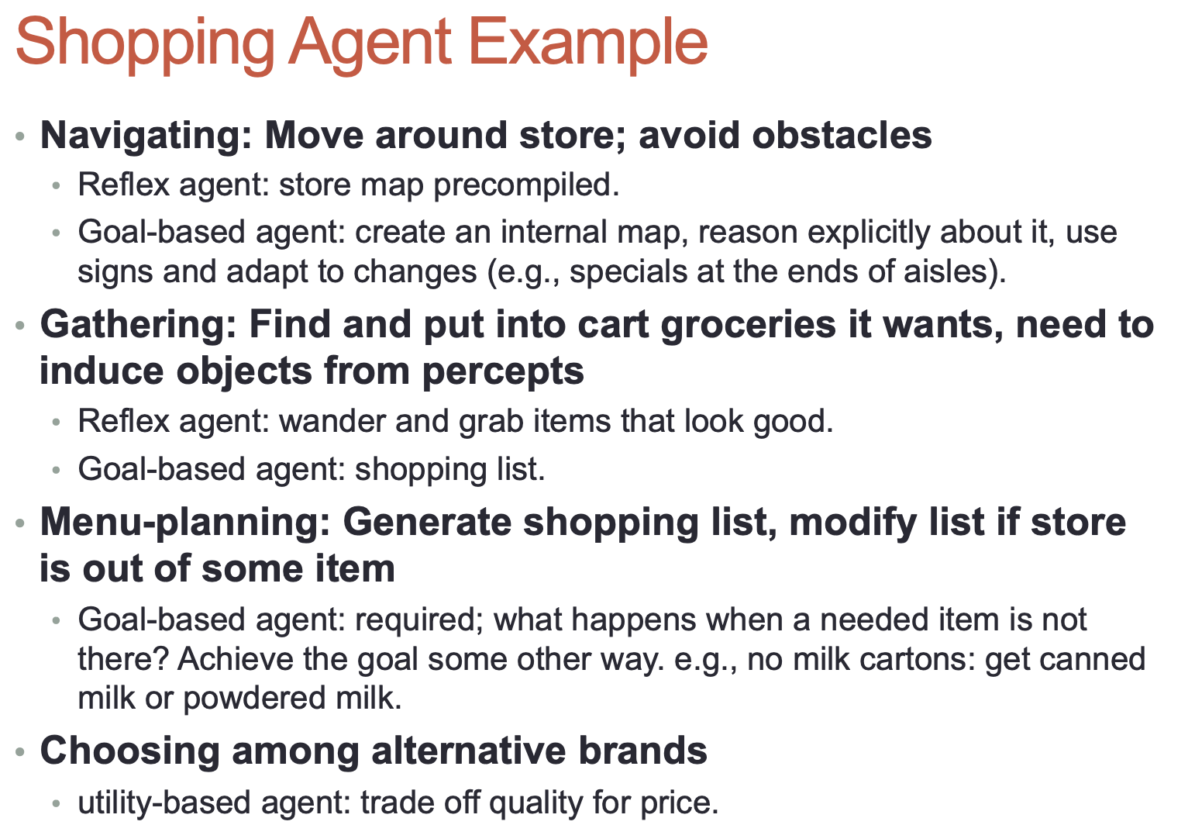

## **Learning Agent**

